**First project**

**Exploring Weather Trends**

Using the Udacity workspace that is connected to the database write this SQL query to extract the city level data and the global data

صورة تحتوي على لقطة شاشة

تم إنشاء الوصف تلقائياً

And then choose Download CSV to download the output of extracting this query

صورة تحتوي على لقطة شاشة

تم إنشاء الوصف تلقائياً

After downloading the file open it using the Excel and it will be look like that

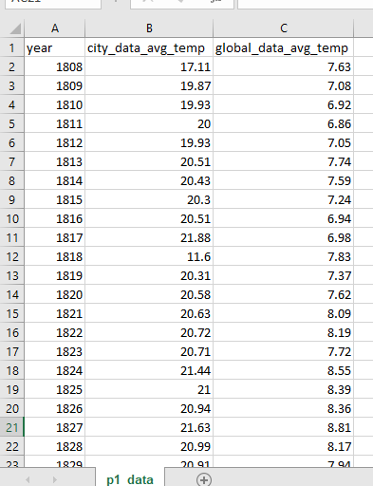

After that calculate the moving average for the city_data_avg_temp and the global_data_avg_temp columns (here I used the average of 5 years) to calculate it you should create another two columns and name them any names and make the first one for the city and the second one for the global temperature and here I used the average of five years so I started from the fifth year and use the AVERAGE() function to calculate the average temperatures for the first five years of my city (Cairo) then use Copy + Paste, Ctrl + D, or click and drag the formula down to the next cells and repeat these steps to calculate the moving average for the global temperatures.

[After that the Excel sheet will be like that](https://classroom.udacity.com/nanodegrees/nd002-ent/parts/978b95a2-2fa2-4263-a2a7-b0e0015ddb5e/modules/23fd1baf-2377-4fa8-87f1-052bd78922d6/lessons/d551938c-d004-4801-a269-4b8dd784cc3b/concepts/0f213a2e-ab83-42a5-be47-fd52a193c003)

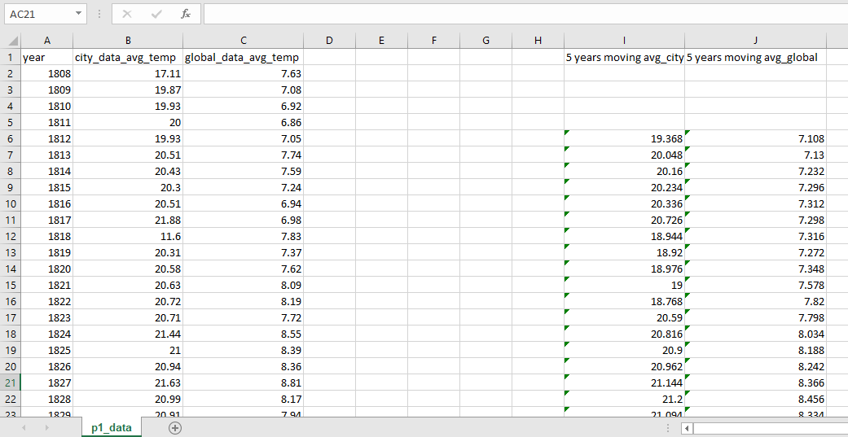

Now we can use the I & J columns instead of the B & C columns to create the line chart and it will be something like that

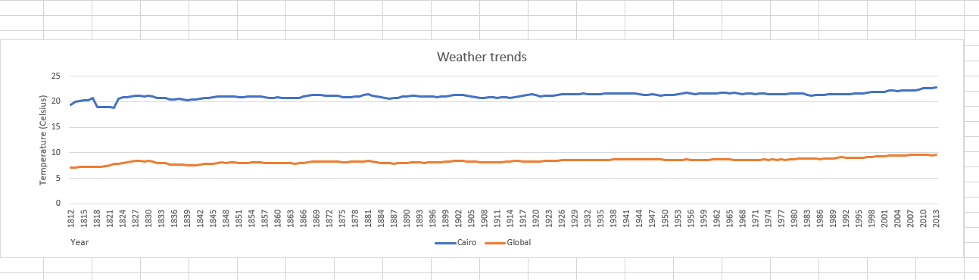

The x axis represents the years and the y axis represents the temperature and the blue line represents the city (Cairo) trends and the orange line represents the global trends.

After looking to the chart take the **observations :-**

1. my city is hotter on average compared to the global average.
2. the difference was Approximately consistent over time but sometimes it differs such as in 1818 the difference get smaller.
3. The correlation is 0.58 ( A moderate uphill (positive) relationship ).
4. The average temperature in my country (Cairo) is 21.16961 and the average temperature in the global is 8.396845.